1. INSERT SELECT statement

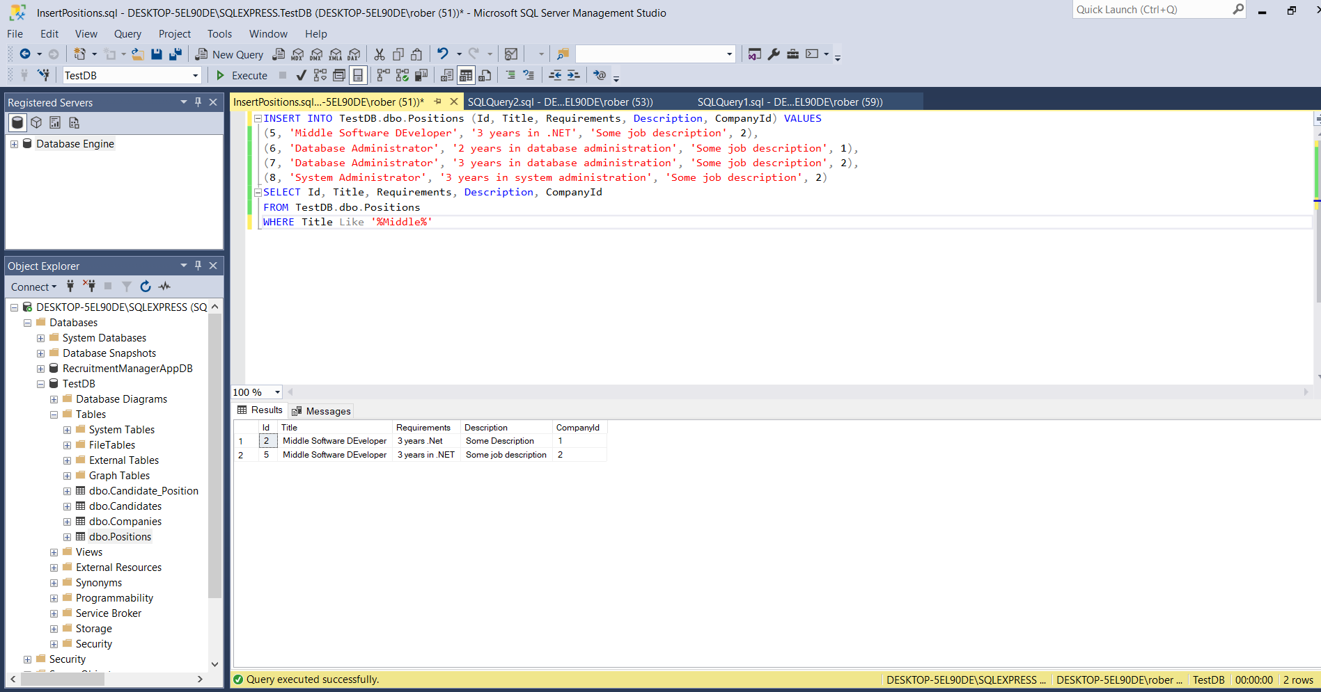

1. Write several grouping queries. Include HaVing clause.

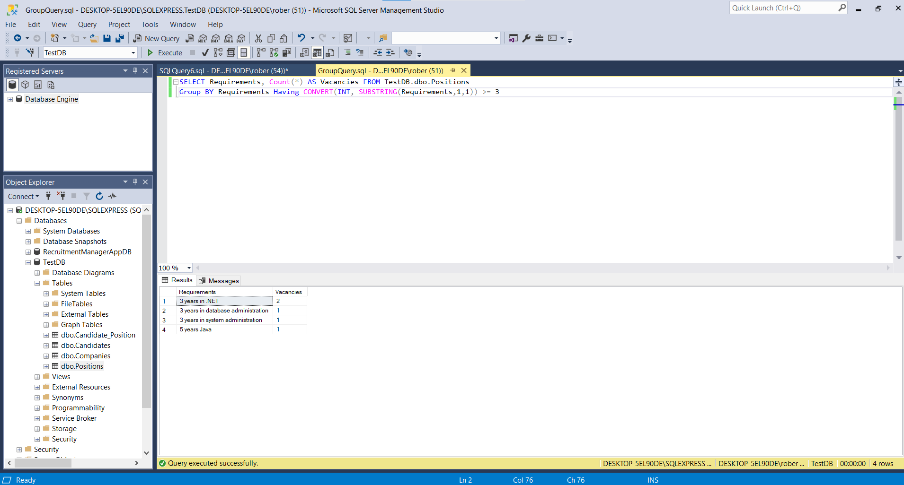

1. Try Out truncate statement

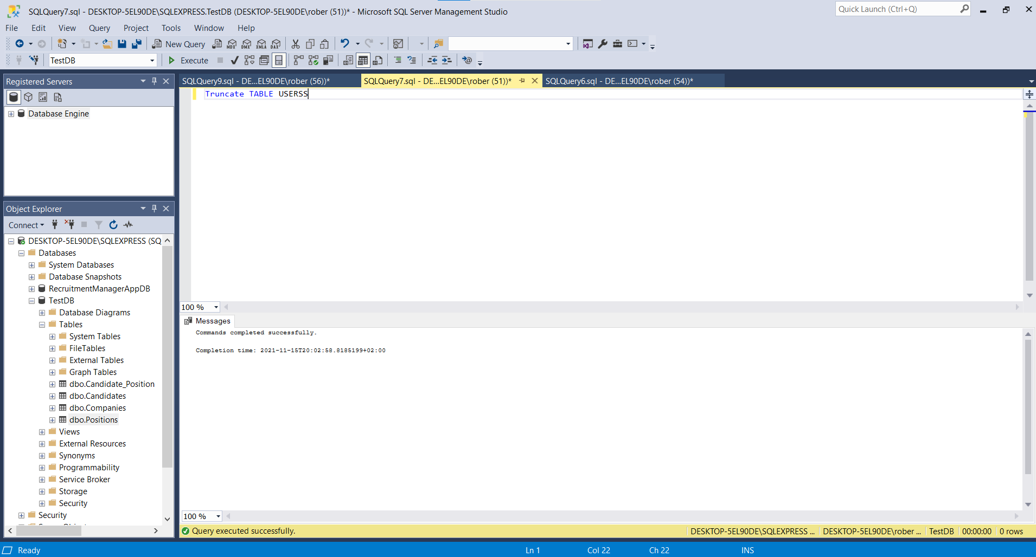

1. Try Out a Delete based on Join with a where clause

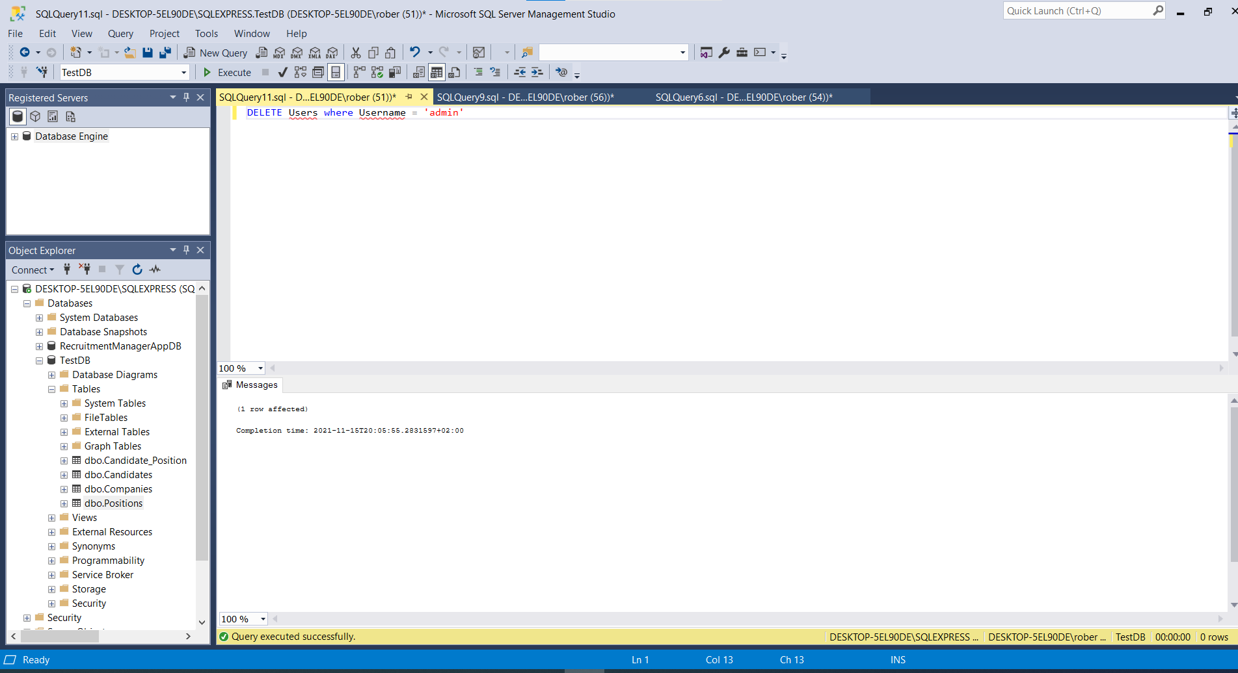

1. Try Out an Update based on Join

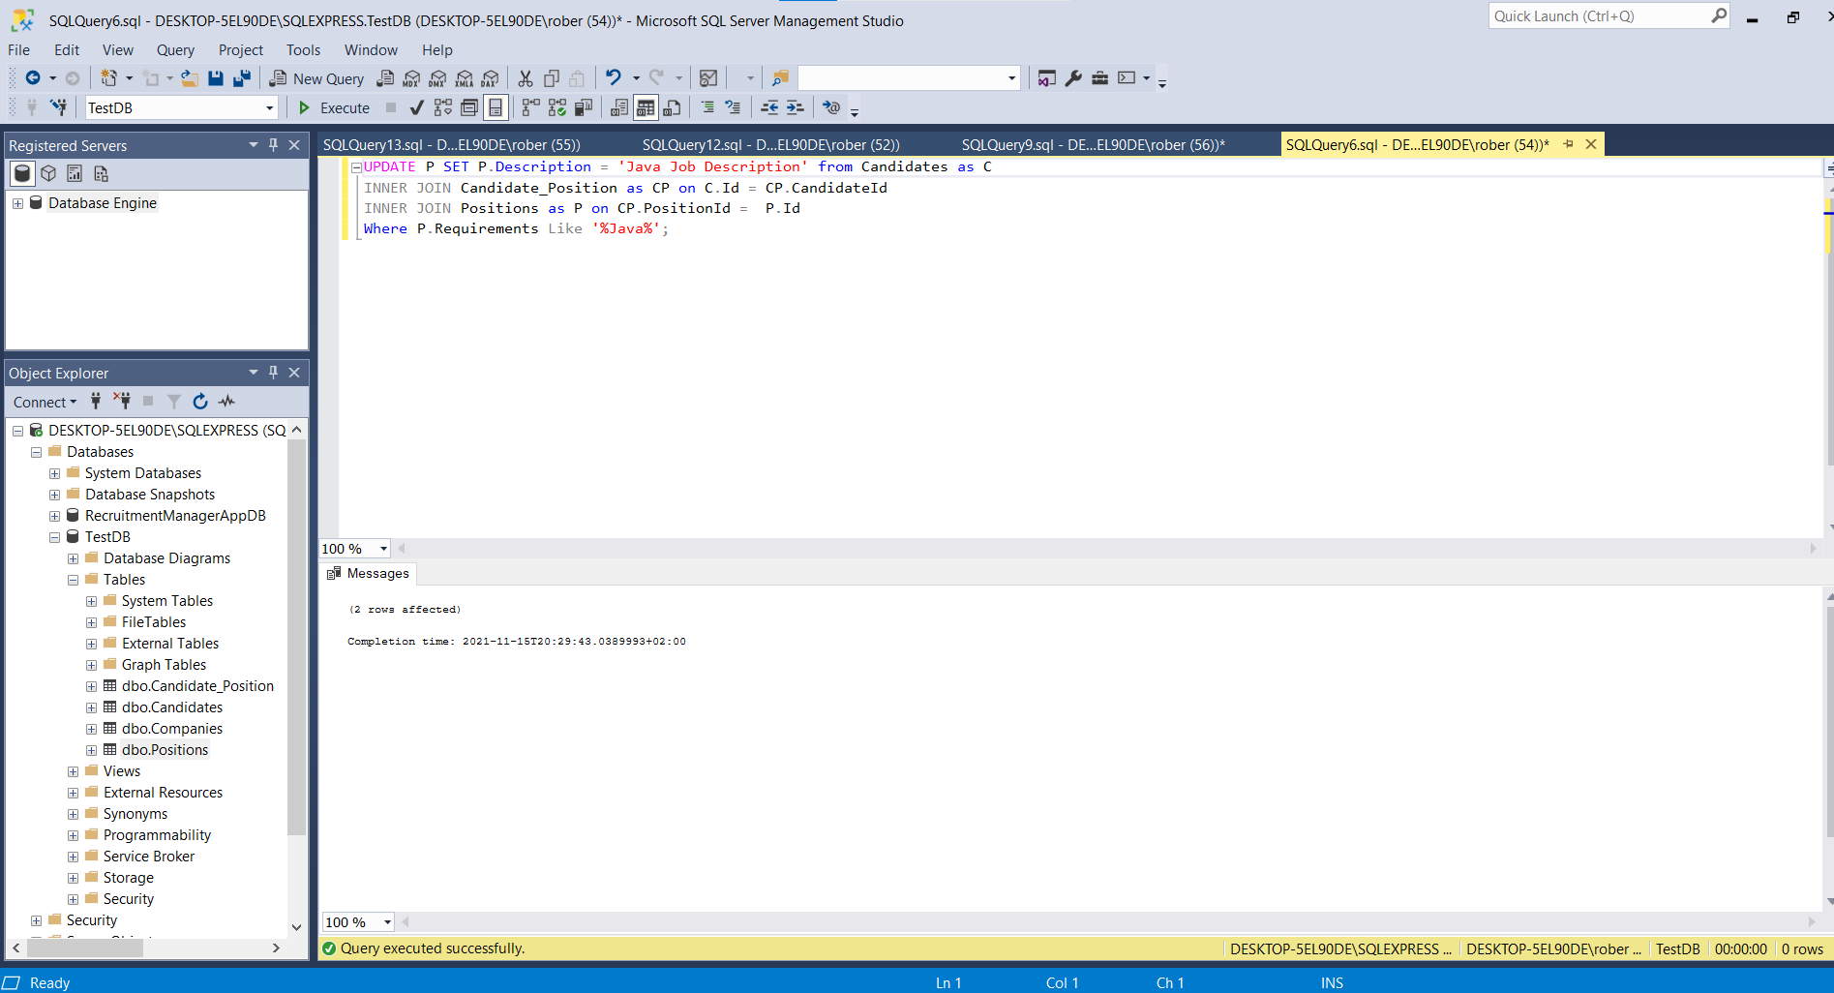

1. Write three correlated Subqueries: one in Select, one in Where and onE in Having.

In the Select Clause:

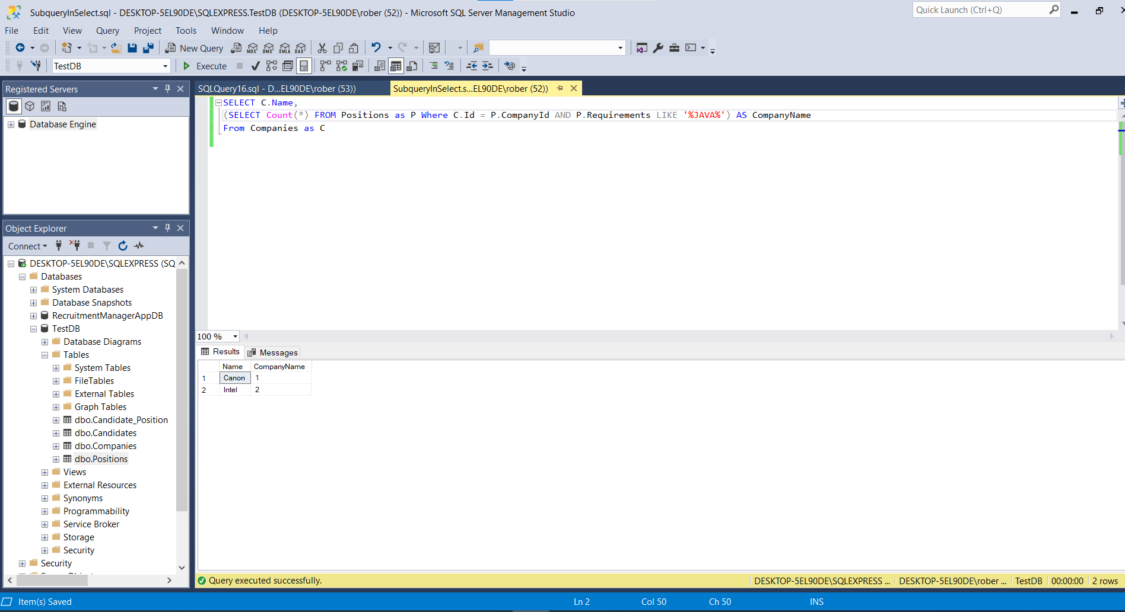

1. Combine queries using in, Exists or not in

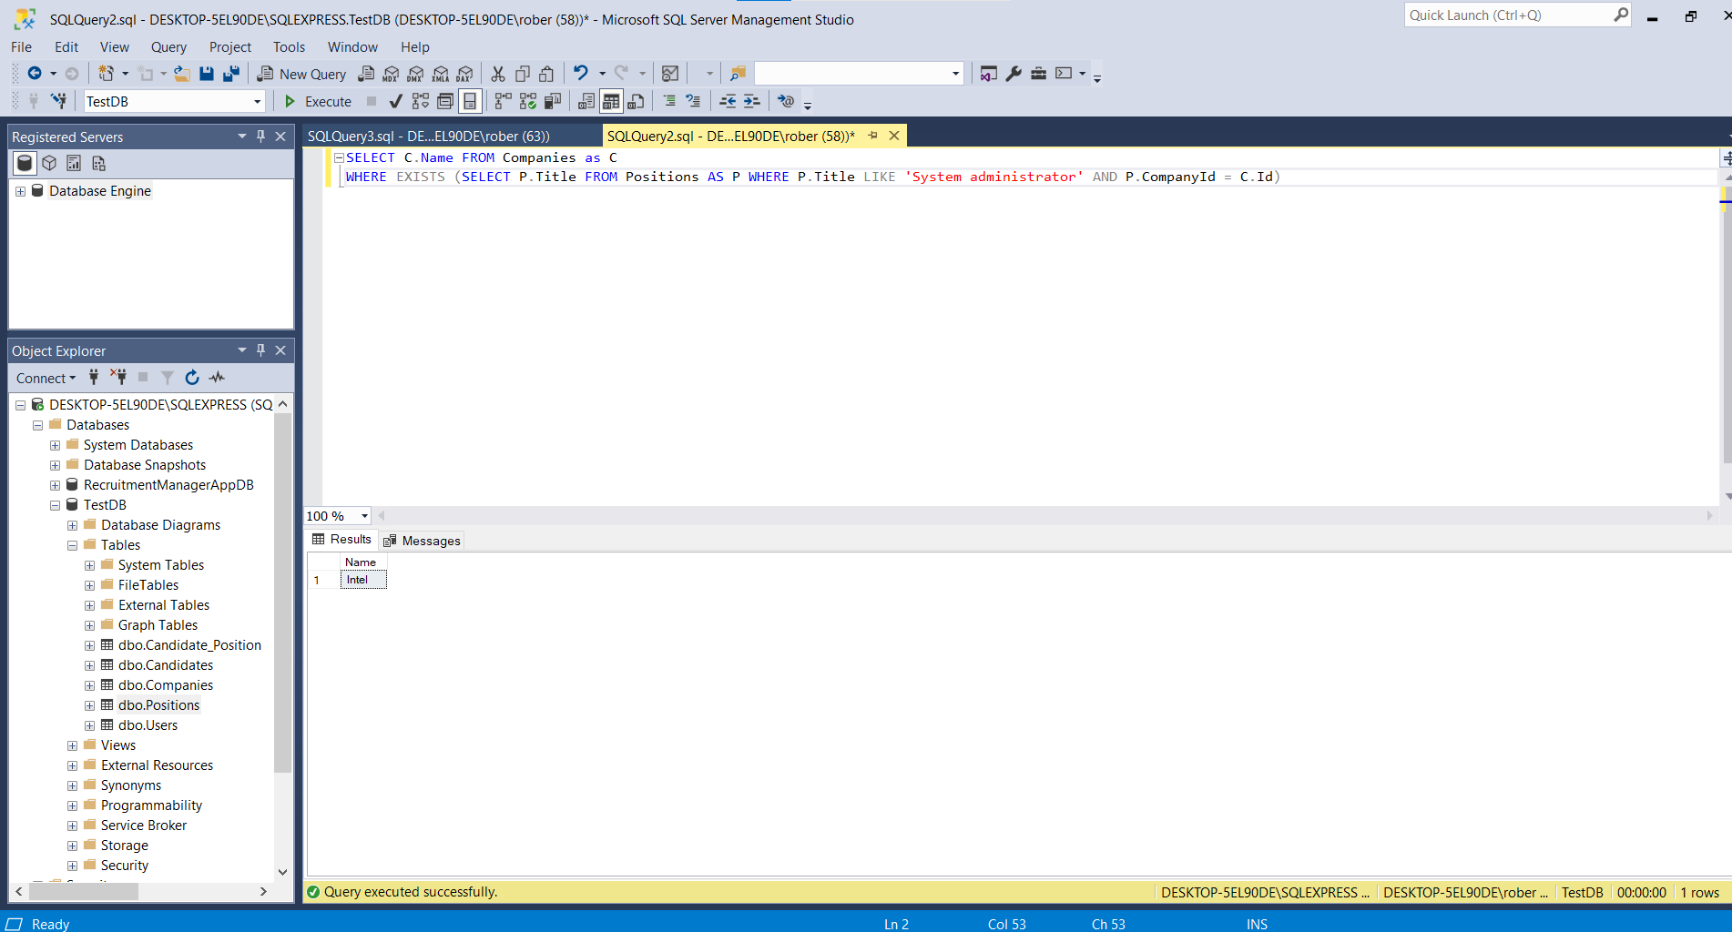

1. Write one query using case in a select statement

